LSC Learning Management System

Project Documentation Submitted
To the Faculty of School of
Computer Science and Information Technology
Of
Asia Pacific College

In Partial Fulfillment of the Requirements for the subject
Applied Projects 2

Gardon, Jana Marie G.
Heramia, Johanna Marisse C.
Tadeo, Jose Lorenzo G.

Table of Contents

Page no

LSC Learning Management System 1
I. Narrative 3
A. Executive Summary 3
B. Introduction 3
1. Client Profile 3
2. Project Organization 3
a. Project Team 3
b. Project Professor 4
c. Project Adviser(s) 4
3. Client’s Mission and Objectives 4
4. Project Objectives 4
5. Purpose of the Project 5
6. Rationale of the Project 5
a. The Current Process Flow 5
b. User Information Needs 6
c. How the Information is being processed? 6
C. Systems Features and Functions 6
1. Software Environment 7
a. Programming Languages 7
b. Specific Software 7
c. Web Server Application 7
d. Operating System 7
2. Hardware Environment 7
3. Networking and Security 7
a. Security 7
b. Server 8
4. Application System Modules 8
a. Quiz 8
b. Course 8
c. User 8
II. System Diagrams and Screenshots 9
A. Data Flow Diagrams 9
1. Context Level Data Flow Diagram 9
2. Level 0 Data Flow Diagram 9
B. UML Diagrams 10
C. Entity – Relationship Diagram 27
D. Data Dictionary 28
E. Screenshots 32
F. Lessons Learn 34

III. Appendices 34

Narrative

Executive Summary
The Loyola Student Center (LSC) Learning Management System is for the students and for the management of Loyola Student Center. This system will be able help the student to track or analyze their performance based on the results of their completed tasks. Through the student’s analyzation, they will be able to know whether they need more improvement on their performance in class. Also, student can be notified easily if there are announcement(s) from their respective tutors in their classed. In the management side, system could help them through management of the student's courses, tasks and attendance. Under a course that is created by the tutor, there are specific tasks that they can create, update or delete.

Introduction

Client Profile
In the early 1980’s, a group of faculty members from the University of the Philippines and the Ateneo de Manila University got together to provide tutorial services in their spare time to children of faculty and staff of the two universities. As more and more students from these and other schools availed of their services, some of these educators opted to undertake tutoring full-time. One of them established, in 1986, a tutorial and review facility at a strategic location on Katipunan Avenue. This became known as the Solomon’s Ark Computer & Tutorial Services Center. After 5 years, its name was changed to the Loyola Student Center. From a handful of students that year, LSC’s clientele has increased considerably. Over the past 23 years, LSC has helped over 22, 000 students perform better in school. Today LSC takes leadership in providing high-quality and affordable tutorial and review services to students not only in Metro Manila but also from the provinces.

Project Organization

Project Team
Name | Position | Email
Jana Marie Gardon | Project Manager | jggardon@student.apc.edu.ph
Johanna Marisse Heramia | Project Member | jcheramia@student.apc.edu.ph
Jose Lorenzo Tadeo | Project Member | jgtadeo@student.apc.edu.ph

Project Professor
Name | Position | Email
Mr. Manuel Sanchez | Professor | manuels@apc.edu.ph

Project Adviser(s)
Name | Position | Email
Ms. Roselle Gardon | Adviser | roselleg@apc.edu.ph
Mr. Jojo Castillo | Consultant | jojoc@apc.edu.ph
Mr. Allan Cotecson | Consultant | allanc@apc.edu.ph
Mr. Francis Uñalivia | Consultant | francisu@apc.edu.ph

Client’s Mission and Objectives
Mission
Our mission is to enhance the intellectual development of students in the Philippines by augmenting the learning they receive from the educational system. We aim to accomplish this by providing the most comprehensive and highest quality tutorials and review services, maintaining competent and progressive teaching and support staff, continually updating our books and materials, and providing an environment conducive to learning and achievement.
Vision
We aspire to become a center of educational excellence and a resource for sectors of our society deprived of opportunities for advance learning. We desire to see the students we help achieve their educational goals – from the simplest one of passing their school quizzes to developing their character and critical thinking skills - so that they may become successful members of society and contribute to the development of the country.

Project Objectives
General Objectives
- To provide student an efficient way of learning by using the Learning Management System
- To provide student an efficient way of learning by using the Learning Management System
- To give the student a faster tracking of their performance to know what is needed to improve
- To provide easier administration of every class.
Specific Objectives
- To provide the Loyola Student center with a system for the learning management system and a database for their requirements.
- For faster administration of records of the task, grades and attendance of students in classes.
- For tutors to announce updates faster and those announcements can see right away by the students in each class.
- For the students of Loyola Student Center to have easier access on their progress online.

Purpose of the Project
The Loyola Student Center current system's difficulty will be improvise by having LSC Learning Management System. It helps the student and administrator or tutor to have easier administration, faster administration of student's records online, taking activity, efficient way of gathering reports and summarization of student's performance. The following are the propose system's improvement:
- The student can view schedule online.
- The student can view summary of grades together with the attendance.
- The student can take exercise, homework or quiz online.
- The student can easily update information if there are any changes.
- The student's tutor can easily view student's attendance, can view summary of grades, can update or add exercises, homework and quizzes.

Rationale of the Project

The Current Process Flow
The following are the Loyola Student Center’s current system:
- The schedule is given by the instructor manually and the student will write it on a paper.
- The student’s summary of grades cannot be seen by the student unless student asks or the test’s result is given by a professor.
- The activity of the student such as assignments or quizzes is paper based.

User Information Needs

How the Information is being processed?

Systems Features and Functions
The LSC Learning Management System is provided for the LSC and students of LSC. Before the student or employee could do the following, he must have an account first.

These are the functionalities of the system for the tutors or instructor:
- Can create a course for review class for the students.
- Can record the student’s attendance during the class.
- Can create and assign task such as assignments, quizzes and exercises.
- Can give announcements through the calendar.

These are the functionalities of the system for the students:
- Can access the review class.
- Can view their attendance.
- Can take tasks.
- Can see the announcements through calendar.
- Can keep track with their grades.

Software Environment

Programming Languages
The programming languages that is use to create the system are:
- HTML
- CSS
- PHP
- JQuery
- Bootstrap

Specific Software
The needed software interfaces to use the LSC LMS are the following:
- Windows, Linux and Android operating system environment.
- The graphical user interfaces and other parts of the LSC LMS software are to be done using the Yii2 advanced framework. It uses HMTL, CSS, PHP 5.4, Bootstrap, JQuery, etc.
- The output of the software will need a browser (e.g. Chrome, Internet Explorer, Firefox, Microsoft Edge, Safari) for viewing it.
- The database in use is MySQL.
- The LSC LMS is dependent to the LSC Enrollment System, so it must be integrated with the Enrollment System.

Web Server Application

Operating System

Hardware Environment
System Requirement
Processor | At least 1.3 GHz processor or faster
Memory | 128 MB RAM (256 MB Recommended)
Disk space | 80GB or above
Screen resolution | At least 800 x 600 colors or above

Networking and Security

Security
The security requirement of the LSC are, only the approved students of the LSC can access the LSC-LMS and the task that will be given by LSC such as assignments and exercises should not be printed or saved in any devices. The team’s solution for both security requirements are, the students email and password will be created when the administration of the LSC approved of his or her account. The information is secured and accessed only between LSC students and employees only since the students can only have an account when he/she is already enrolled. Moreover, there will be no access to LMS once the student is already unenrolled. Regarding with the task security, the team came up with the solution of “not right clickable” making the task unprintable and not downloadable.
- The LSC LMS will run inside a firewall for security
- The LSC LMS will support different roles for users such as tutors, students and system administrator. The user logged in with given role should only be allowed with that role (e.g. Student will only be allowed to see his or her grades not to change it.).
- In HTTPS, it enables access to web application to secure access of the confidential data such as the student’s data. The Administrator of LSC LMS will have full database administration control and tutors may have access to copy of some parts of database for editing purposes.
- The LSC’s materials for quizzes shall not be printed and downloadable.

Server

Application System Modules

Quiz

Course

User

System Diagrams and Screenshots

Data Flow Diagrams

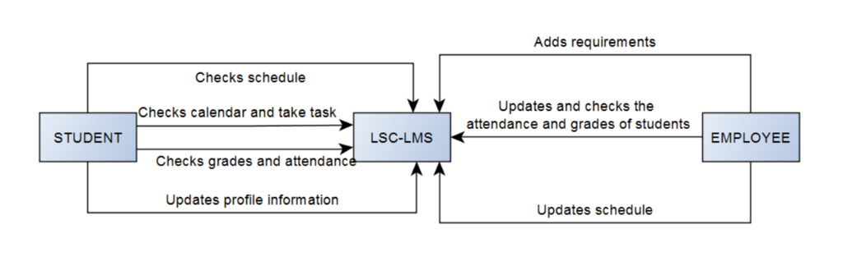
Context Level Data Flow Diagram

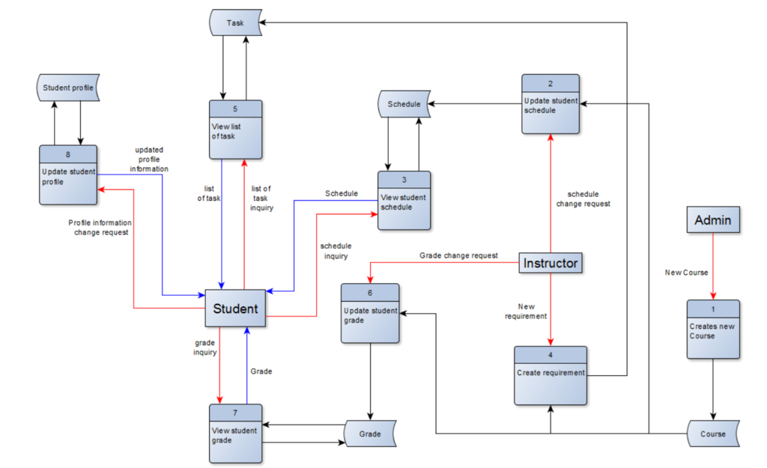
Level 0 Data Flow Diagram

UML Diagrams

Use Case Diagram
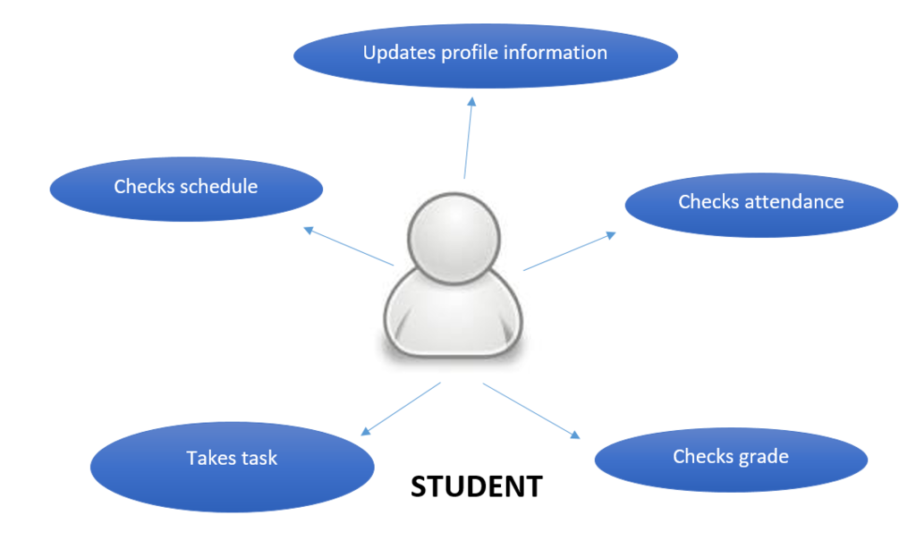

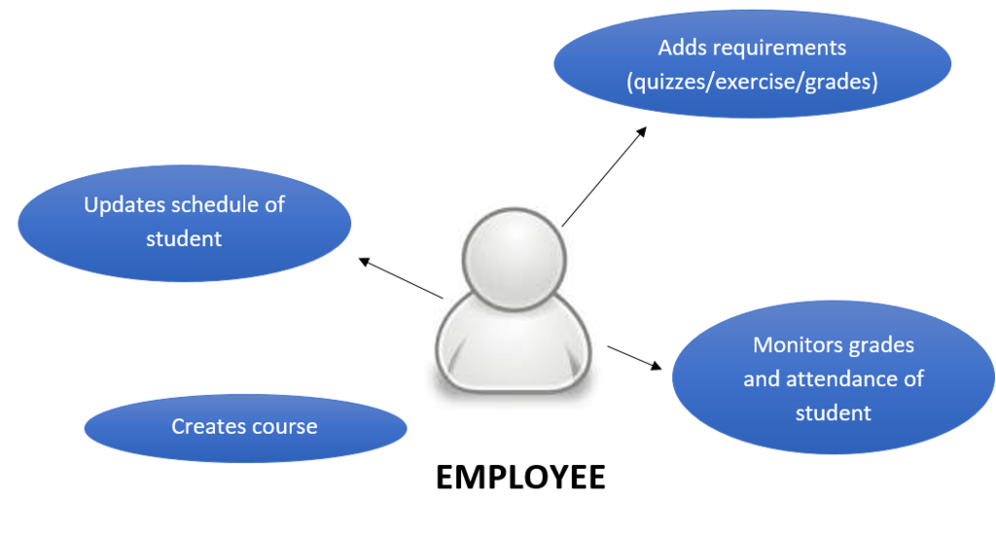

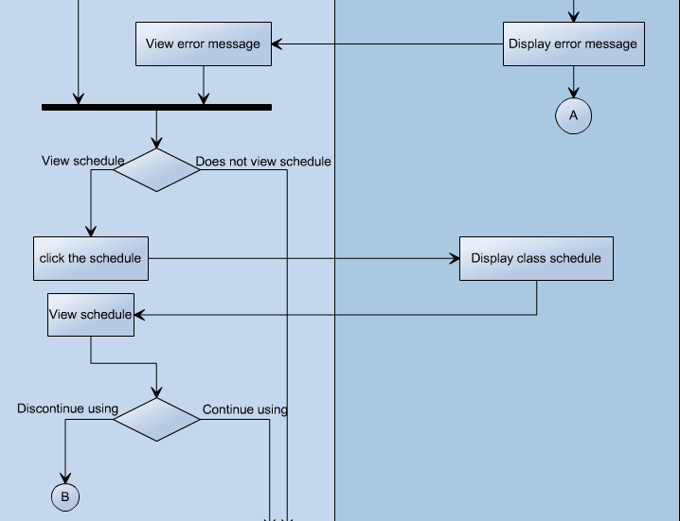
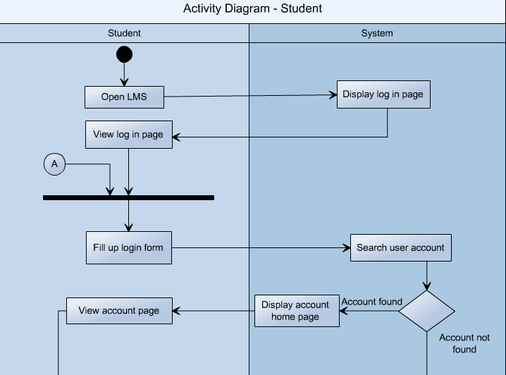

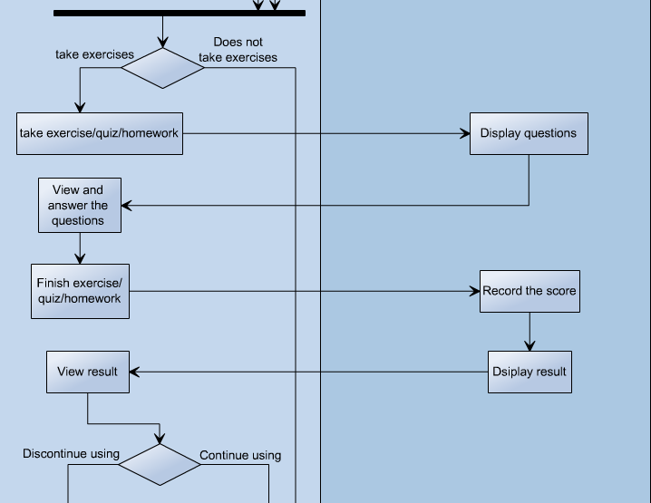

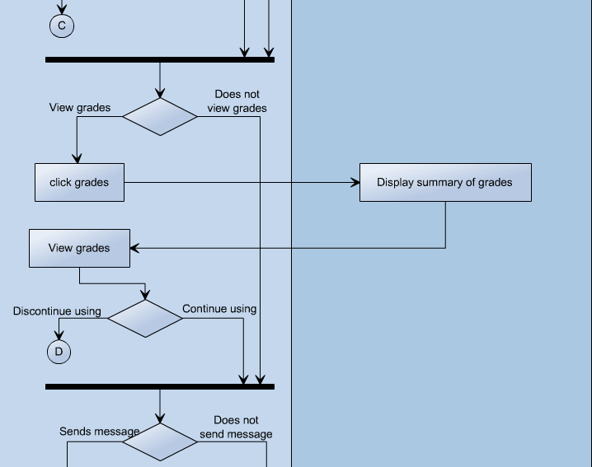

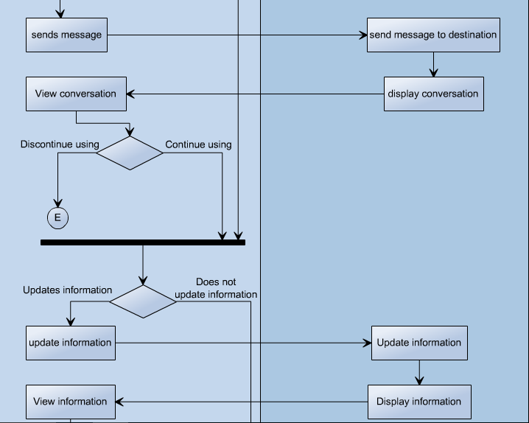

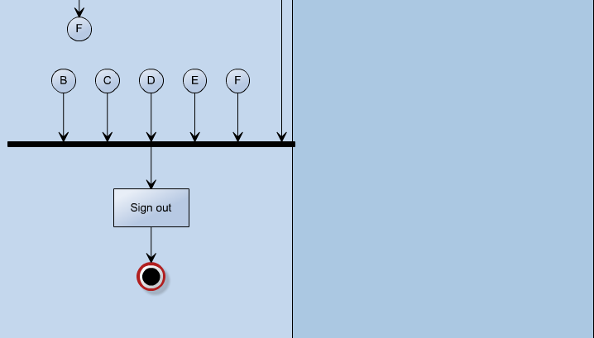

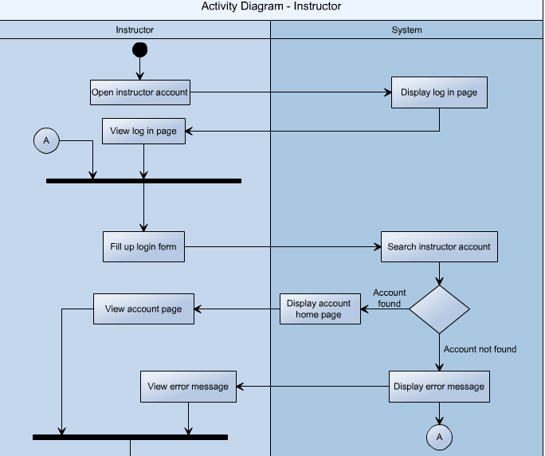

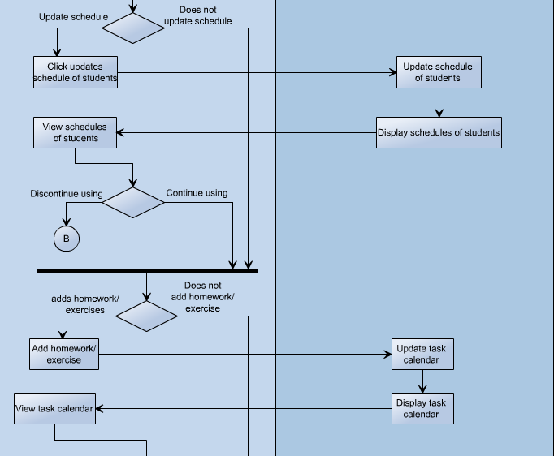

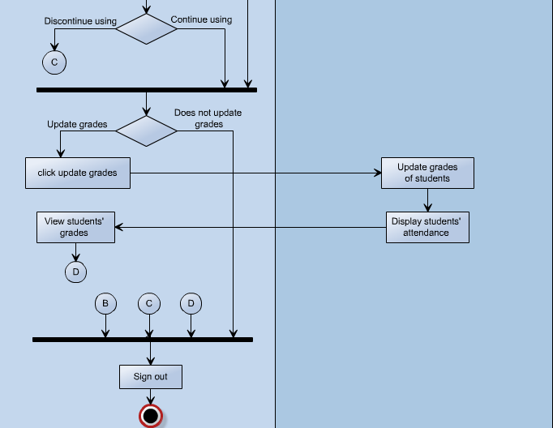
11

Object Diagram
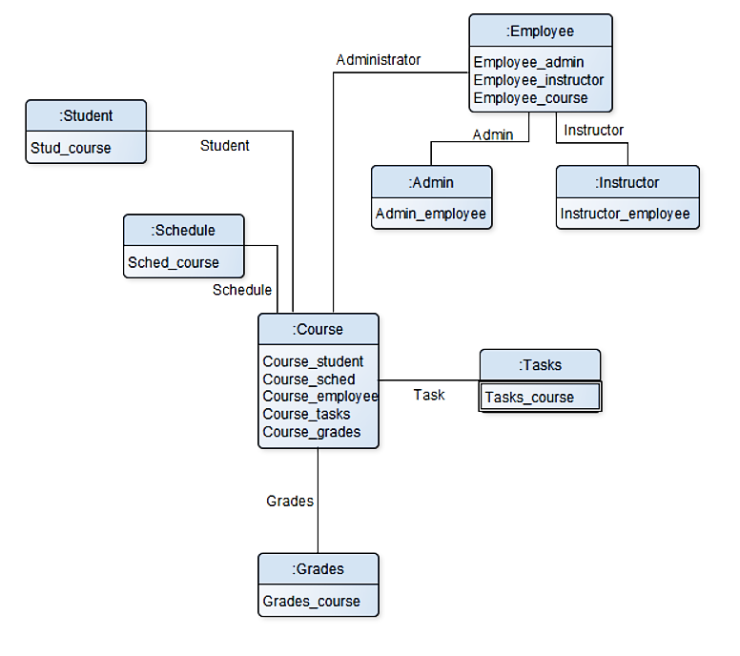

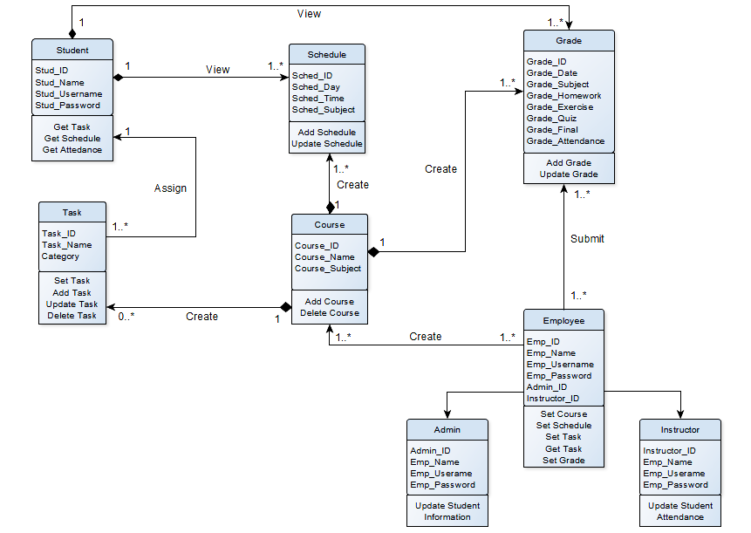
Class Diagram

Communication Diagram
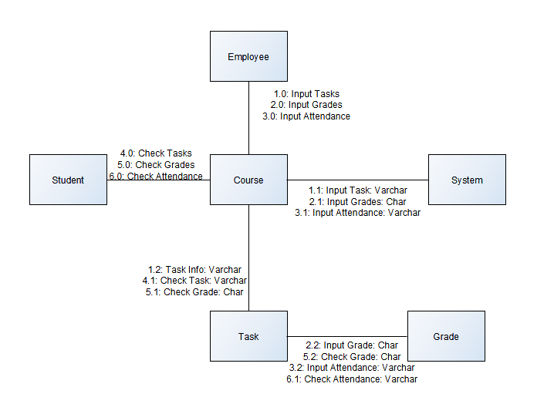
State Machine Diagram
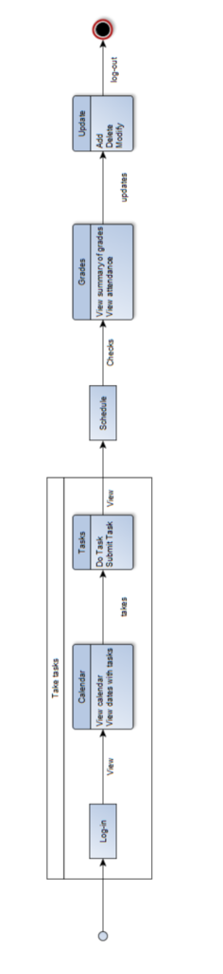
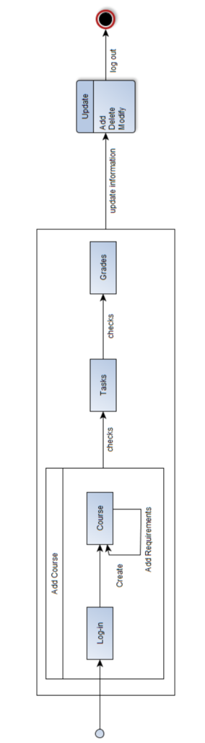

Timing Diagram

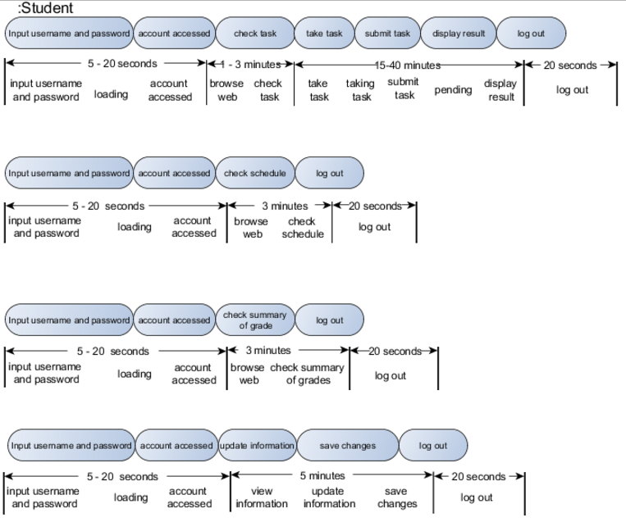

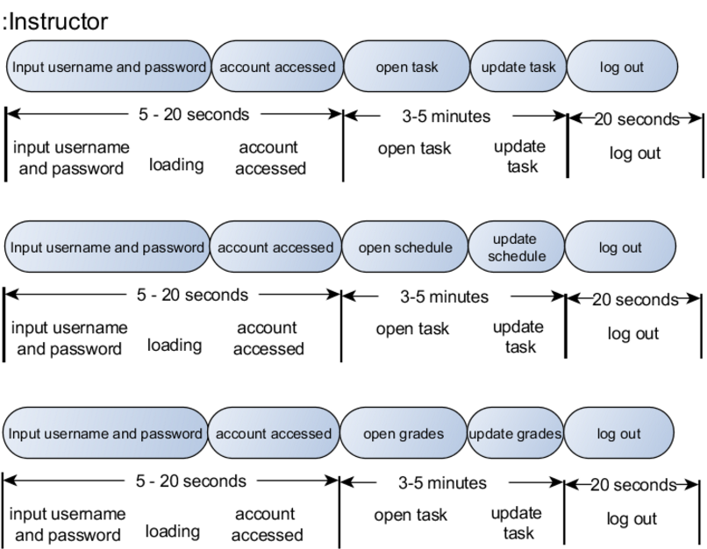

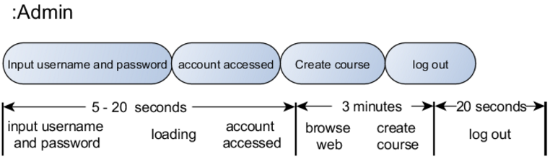

Component Diagram

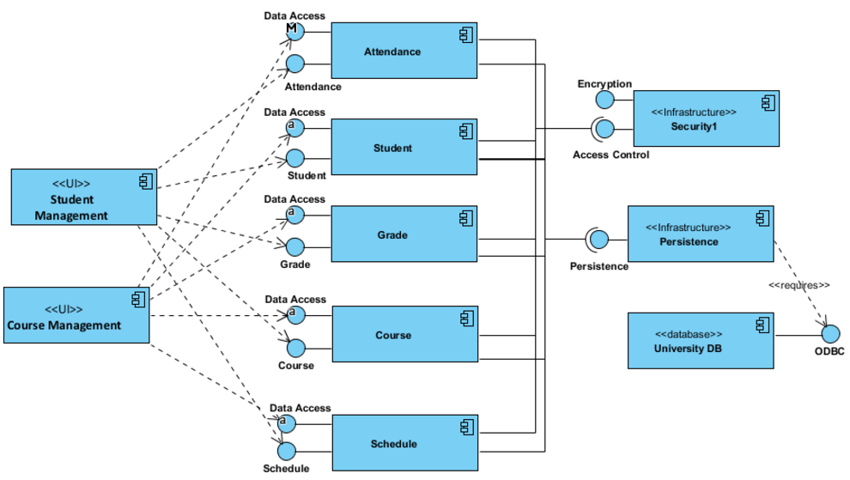

Package Diagram

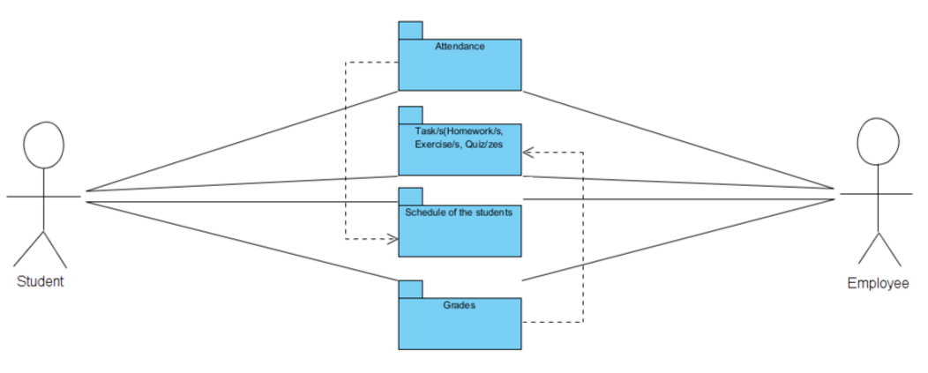

Package Diagram

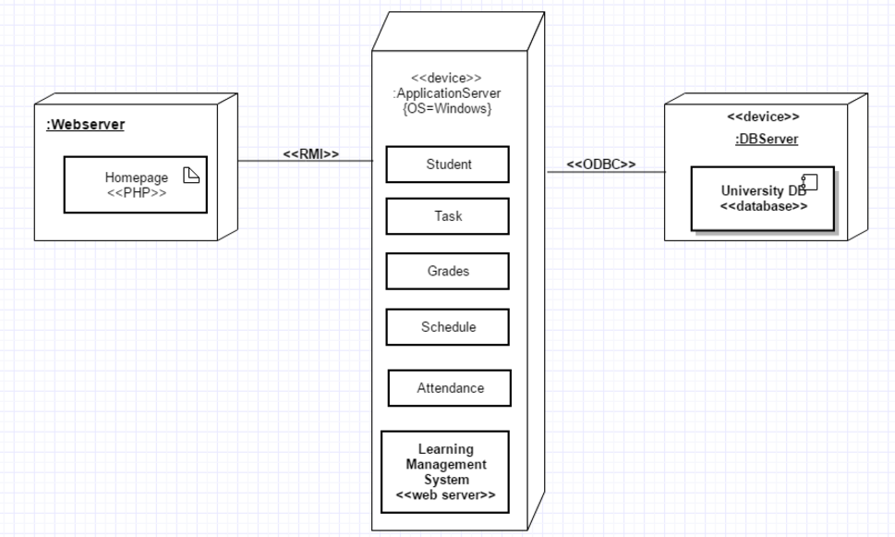

Sequence Diagram

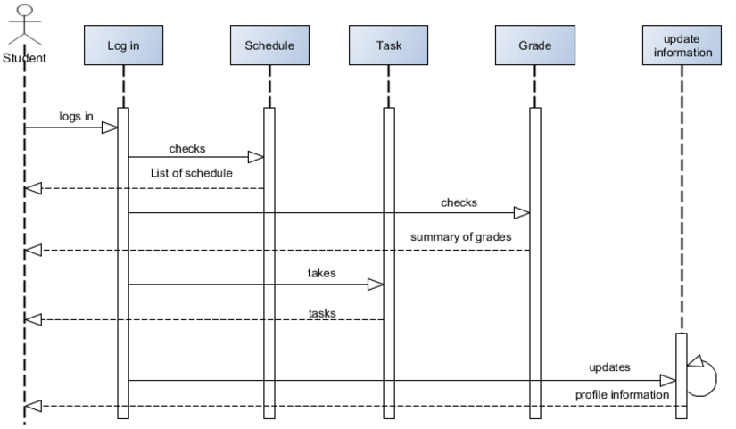

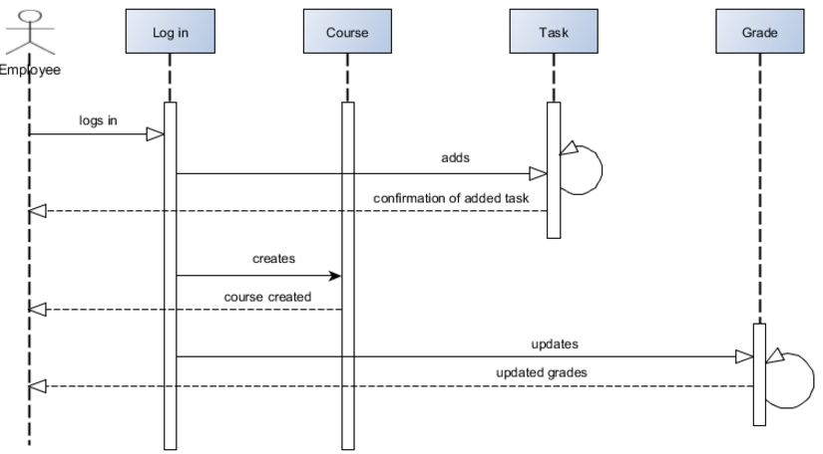

Composite Diagram
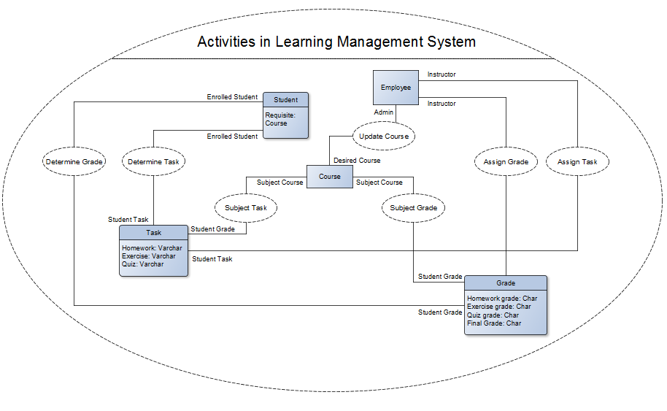

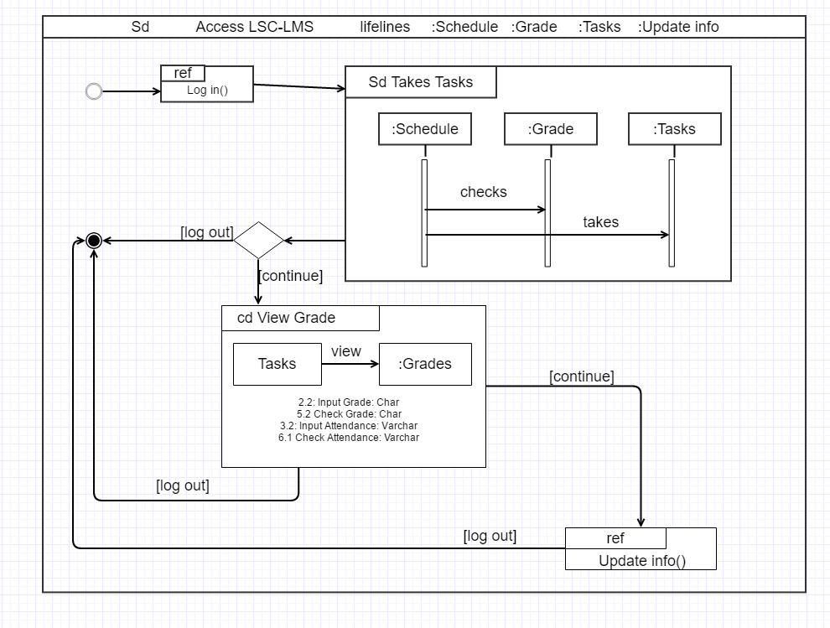
Interaction Diagram

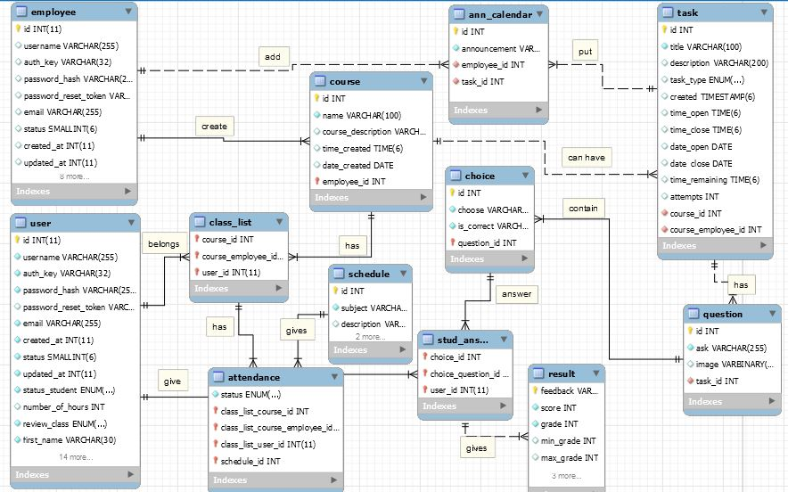
Entity – Relationship Diagram

Data Dictionary
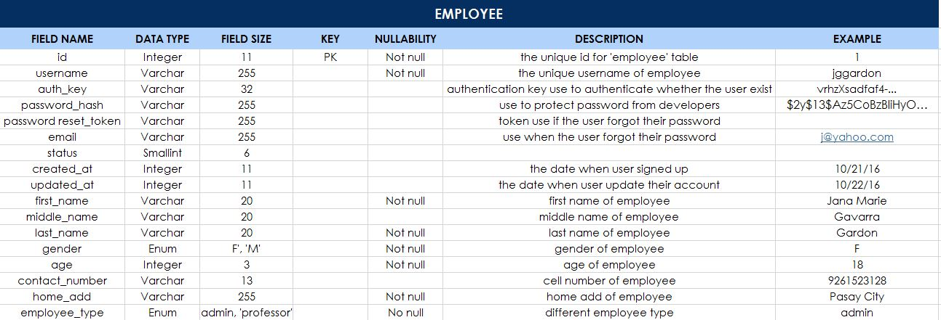

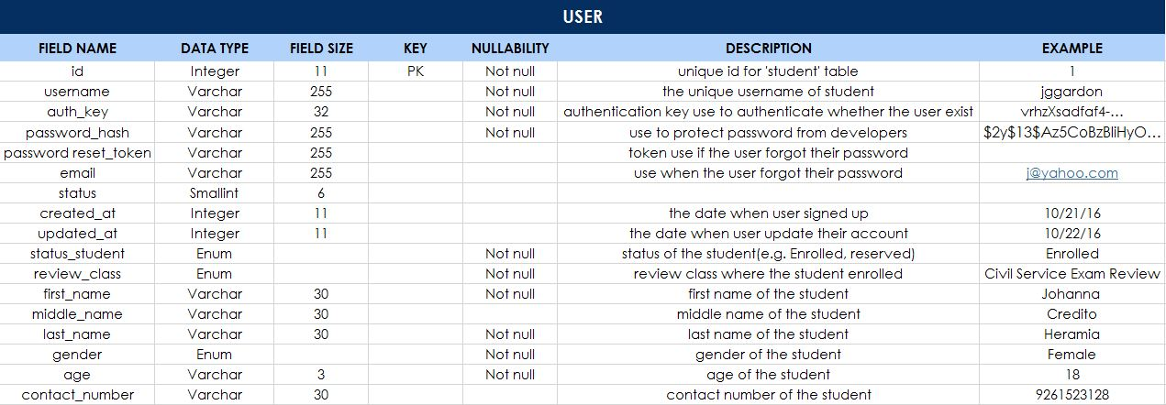
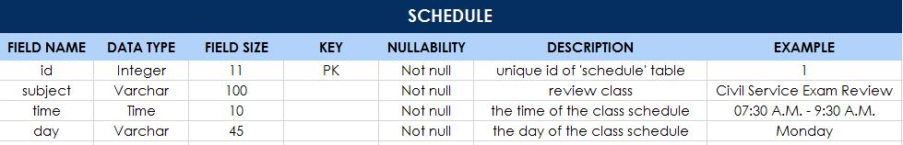

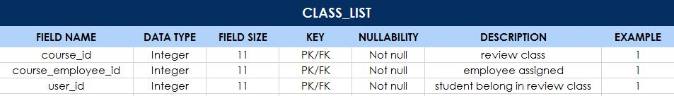

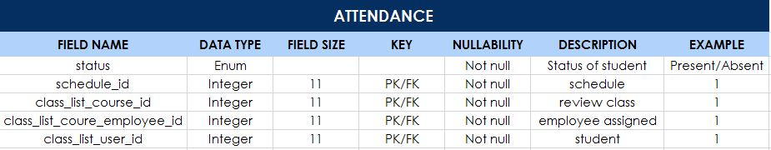

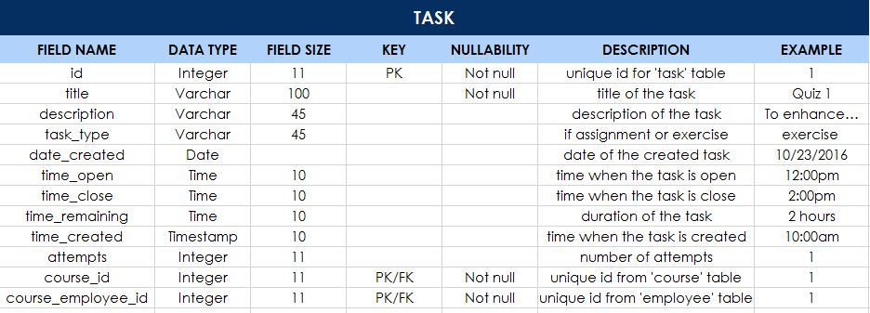

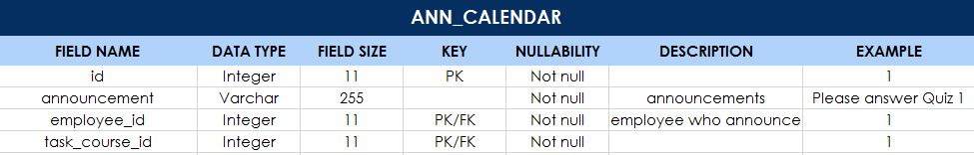

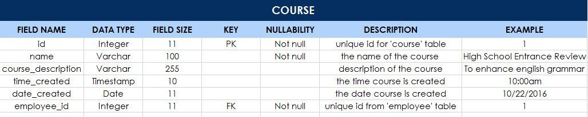

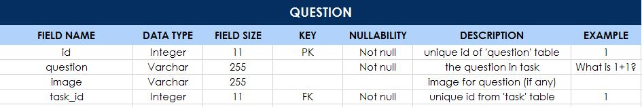

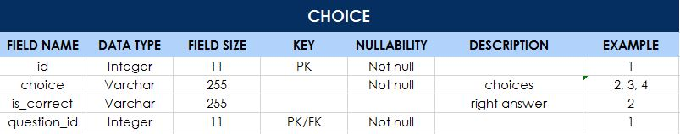

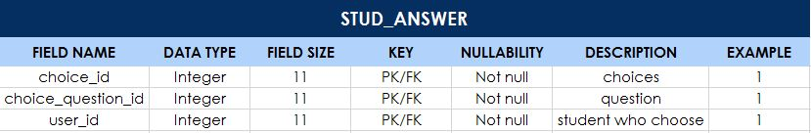

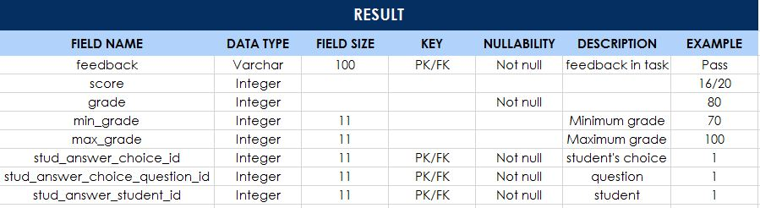

Screenshots
Frontend

Login page
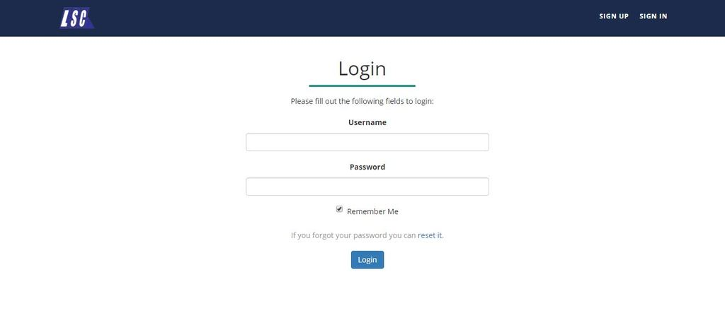

Main page
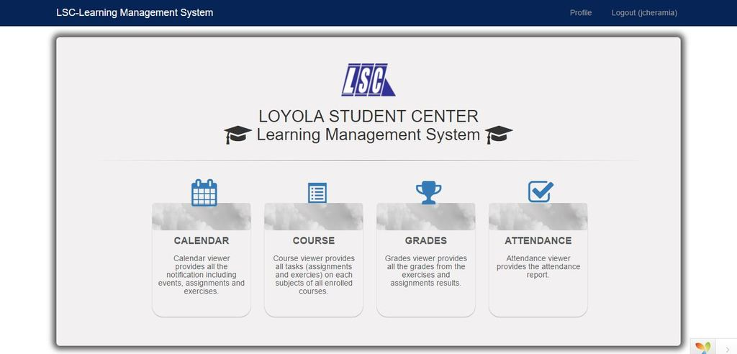

Backend

Login
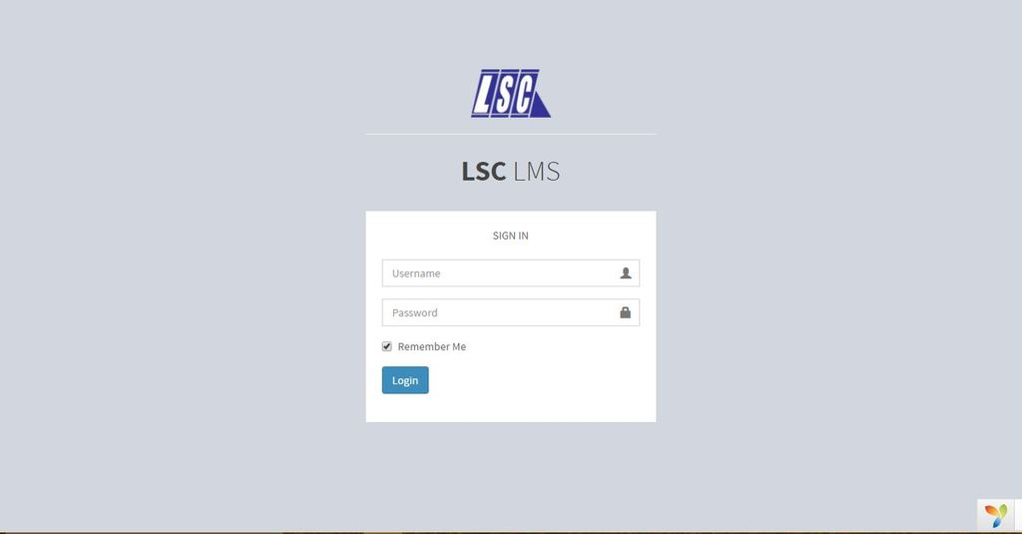

Main page
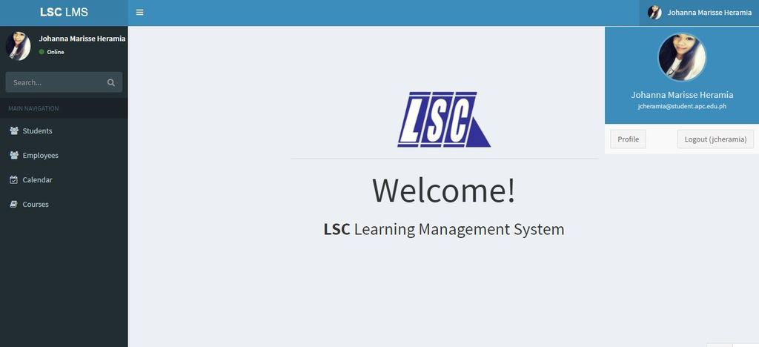

Lessons Learn

Appendices

Appendix A: Glossary

Backend - Denoting a subordinate processor or program, not directly accessed by the user, which performs a specialized function on behalf of a main processor or software system.

Constraint – Limitation or restriction

Data - A collection of facts from which conclusions may be drawn.

Diagram - A drawing intended to explain how something works; a drawing showing the relation between the parts.

Frontend - directly accessed by the user and allowing access to further devices, programs, or databases.

Hardware - the machines, wiring, and other physical components of a computer or other electronic system.

Interface - a visual way of interacting with a computer using items such as windows, icons, and menus, used by most modern operating systems.

Operating system - the software that supports a computer's basic functions, such as scheduling tasks, executing applications, and controlling peripherals.

Software - the programs and other operating information used by a computer.

System - a set of connected things or parts forming a complex whole, in particular.

Tracking - the maintenance of a constant difference in frequency between two or more connected circuits or components.

Appendix B: Other Requirements

Change Management Plan
LSC Learning Management System

Asia Pacific College
3 Humabon Place, Magallanes
Makati City

Gardon, Jana Marie G.
Heramia, Johanna Marisse C.
Tadeo, Jose Lorenzo Tadeo

December 14, 2016

INTRODUCTION
The Change Management Plan is created for LSC Learning Management System to ensure that the project is on the right track and knowing what should and should not include in the project to guarantee the project content is within the scope. Managing the project is keeping up with its changes, define changes and knowing the purpose and role of the change control board. It is assumed that all the stakeholders will submit or request changes to the LSC-LMS project in line with this Change Management Plan and changes will apply to all request and submissions based on the process detailed herein.

CHANGE MANAGEMENT APPROACH
The Change Management approach for the LSC Learning Management System Project will ensure that all proposed changes are defined, reviewed, and agreed upon so they can be properly implemented and communicated to all stakeholders. This approach will also ensure that only changes within the scope of this project are approved and implemented.

The Change Management approach is not to be confused with the Change Management Process which will be detailed later in this plan. The Change Management approach consists of three areas:
- Ensure changes are within scope and beneficial to the project
- Determine how the change will be implemented
- Manage the change as it is implemented

The Change Management process has been designed to make sure this approach is followed for all changes. By using this approach methodology, the LSC Learning Management System Project Team will prevent unnecessary change from occurring and focus its resources only on beneficial changes within the project scope.

DEFINITIONS OF CHANGE
There are several types of changes which may be requested and considered for the LSC Learning Management System Project. Depending on the extent and type of proposed changes, changes project documentation and the communication of these changes will be required to include any approved changes into the project plan and ensure all stakeholders are notified. Types of changes include:

- Scheduling Changes: changes which will impact the approved project schedule. These changes may require fast tracking, crashing, or re-baselining the schedule depending on the significance of the impact.
- Budget Changes: changes which will impact the approved project budget. These changes may require requesting additional funding, releasing funding which would no longer be required, or adding to project or management reserves. May require changes to the cost baseline.
- Scope Changes: changes which are necessary and impact the project’s scope which may be the result of unforeseen requirements which were not initially planned for. These changes may also impact budget and schedule. These changes may require revision to WBS, project scope statement, and other project documentation as necessary.

The project manager must ensure that any approved changes are communicated to the project stakeholders. Additionally, as changes are approved, the project manager must ensure that the changes are captured in the project documentation where necessary. These document updates must then be communicated to the project team and stakeholders as well.

CHANGE CONTROL BOARD
The Change Control Board (CCB) is the approval authority for all proposed change requests pertaining to the LSC Learning Management System Project. The purpose of the CCB is to review all change requests, determine their impacts on the project risk, scope, cost, and schedule, and to approve or deny each change request. The following chart provides a list of the CCB members for the LSC Learning Management System Project:

Name | Position | CCB Role
J. Limos | LSC LMS Project Sponsor | CCB Chair
J. Gardon | LSC LMS Project Manager | CCB Member
R. Gardon | LSC LMS Project Technical Lead | CCB Co-Chair

As change requests are submitted to the LSC Learning Management System Project Manager by the project team/stakeholders, the Project Manager will log the requests in the change log and the CCB will convene every other Friday to review all change requests. For a change request to be approved, all CCB members must vote in favor. In the event more information is needed for a particular change request, the request will be deferred and sent back to the requestor for more information or clarification. If a change is deemed critical, an ad hoc CCB meeting can be called in order to review the change prior to the next scheduled bi-weekly CCB meeting.

ROLES AND RESPONSIBILITIES

The following are the roles and responsibilities for all change management efforts related to the LSC Learning Management System Project:

Project Sponsor:
- Approve all changes to budget/funding allocations
- Approve all changes to schedule baseline
- Approve any changes in project scope
- Chair the CCB

Project Manager:
- Receive and log all change requests from project stakeholders
- Conduct preliminary risk, cost, schedule, scope analysis of change prior to CCB
- Seek clarification from change requestors on any open issues or concerns
- Make documentation revisions/edits as necessary for all approved changes
- Participate on CCB

Project Team/Stakeholders:
- Submit all change requests on standard organizational change request forms
- Provide all applicable information and detail on change request forms
- Be prepared to address questions regarding any submitted change requests
- Provide feedback as necessary on impact of proposed changes

CHANGE CONTROL PROCESS
The Change Control Process for the LSC Learning Management System Project will follow the organizational standard change process for all projects. The project manager has overall responsibility for executing the change management process for each change request.

- Identify the need for a change (Stakeholders) – Change requestor will submit a completed change request form to the project manager.
- Log change in the change request register (Project Manager) – The project manager will keep a log of all submitted change requests throughout the project’s lifecycle.
- Evaluate the change (Project Manager, Team, Requestor) – The project manager will conduct a preliminary analysis on the impact of the change to risk, cost, schedule, and scope and seek clarification from team members and the change requestor.
- Submit change request to CCB (Project Manager) – The project manager will submit the change request, as well as the preliminary analysis, to the CCB for review.
- Obtain Decision on change request (CCB) – The CCB will discuss the proposed change and decide whether or not it will be approved based on all submitted information.
- Implement change (Project Manager) – If a change is approved by the CCB, the project manager will update and re-baseline project documentation as necessary.

SPONSOR ACCEPTANCE

Approved by the Project Sponsor:

__________________________________________ Date: ___________________
<Project Sponsor>
<Project Sponsor Title>

Project Vision and Scope
LSC Learning Management System

Asia Pacific College
3 Humabon Place, Magallanes
Makati City

Gardon, Jana Marie G.
Heramia, Johanna Marisse C.
Tadeo, Jose Lorenzo Tadeo

December 14, 2016

Business Requirements
Loyola Student Center is currently having a paper-based system where their assignments and exercises are presented in papers. The way they record the student’s attendance and scores are through papers as well. The management wanted something that a student can do online where they can give materials that the students can use as a practice at home but can only be accessed by students and by management only. Because of that, we come up with a possible solution of having a learning management system which will benefit both the students and the management that makes their work much faster and easier. Since students have their own account, the data will be more organized; most of their attendance, assignments and exercises will no longer be paper-based and even their schedule can be found in their account. Student will be informed, can review lessons and improve performance based on the results of their exercises. The instructor asses the performance among learners, monitor their participation and create tasks which is all by the use of technology. After their class, the students can still be able to practice the lessons by taking the uploaded exercises.

Background
Loyola Student Center (LSC) has many problems. One of those problems is their way of giving assignments and exercises using the paper-based system. The paper-based system can put an organization at a disadvantage in terms of profits because giving printed papers to each student can be expensive. Another problem is that their way of announcements, the only way that the student can receive the announcement is through their lecturers. After analyzing the problems of LSC, our group came up with a system LSC Learning Management System (LSC LMS). Using LSC LMS can give many advantages such as giving assignments and exercises paperless. Cutting down the expenses in paper can be an advantage in terms of increase in profits. Another advantage of using the LSC LMS is that it can be used as announcements. Giving announcements ahead of time or immediately can make the students of LSC be prepared.

Business Opportunity
A learning management system is efficient to use because it has been already proven and tested by some universities or colleges. Using LSC LMS as a means of imparting knowledge to students by the use of technology. It is a combination of using both physical hardware and educational theories. Most people use technology and might as well use it for learning. There are lots of learning management system that provides different learning materials already but each caters different lessons to students. Two of the existing LMS are Moodle and Learnanywhere where both created to provide learning to students through online which creates task, class curriculum and monitor their performance.
The LSC - Learning Management System differ from other existing LMS because it is made only for LSC students where the learning materials are exclusive for them. The LSC-LMS consists of calendar where it does not only notify the student when there is an upcoming task but also shows the schedule of the student. Unlike other learning management system, the admin can directly check the attendance of the student on the attendance page while the student can view his or her attendance. Results on the activities are recorded and can be viewed by the students. All the contents are useful for the student and is a user-friendly system. Without LMS the way they deliver task to students is still be paper-based. The need to print out paper-based assessment will be reduced. With LMS they can access it anywhere as long as they are connected to the internet. It is also not prone to losing those assessment papers and can still be review as well as measuring the duration of time on answering those test. LSC-LMS let the students be aware of their attendance. All of that are through the use of technology and since technology is widely used by people especially the students, it will be easier for them to takes assignments online and they can adjust easily. They can access it at any given time and is not time consuming from looking for workplace.

Business Objectives and Success Criteria
Business objectives or goals are very significant in creating a project because it provides guidance and direction and it must be measurable and quantifiable given on the limited amount of time. The following are the general and specific objectives or goals of LSC Learning Management System:

General Objective(s):
- To provide student an efficient way of learning by using the Learning Management System.
- To give the students of Loyola Student Center faster tracking of their performance to know what are the needed improvements.
- To provide Loyola Student Center easier administration.

Specific Objective(s):
- To provide the Loyola Student Center with LSC Learning Management System that by upgrading their current processes and database for storing information.
- To provide the Loyola Student Center faster administration of records of tasks, grades and attendance of students.
- For the Loyola Student Center to announce updates faster
- For the students Loyola Student Center to have easier access on their progress online.

Success Criteria(s):
- The LSC Learning Management system meets its objectives.
- The Management of Loyola Student Center is satisfied with the result of the LSC LMS.
- The teachers of LSC can record student’s task, record and attendance.
- The students of LSC can monitor their performance and attendance and can take tasks online.

Customer or Market Needs
Loyola Student Center’s customers and staffs will gain benefits when using the Learning Management System. Viewing of grades willingly, viewing of the number of attendance, checking the availability of the lecturer, carrying less papers during review class, tracking the student’s progress, are some of the needs in the side of the customer. The needs in the side of the staffs are immediate announcements such as availability of the lecturer, the organization of the student’s performance, paper less assignments and exercises. These needs enabled us to make a Learning Management System (LMS) for Loyola Student Center (LSC) so that the customers of LSC will give positive feedback about LSC’s way of processing and to the side of the staffs by providing their best performance with less effort.
The LMS can provide the needs of both the customers and staffs of LSC. Such as the availability to view grades, attendance, and task of the customer. The immediate announcements of the staffs of LSC to their customers. Less papers are needed when doing and handing out assignments and exercises. The organization of the performance of a student. These functionalities will be provided in the LMS. The LMS are incapable of doing such as sending messages to other customers or staffs, posting unnecessary status such as current lectures, check the online users of LMS, and viewing other customers’ profiles and performance.

Business Risks
Not all the improvements in business are always positive. Every improvement and every change have risks and it must be known in order for the organization to be prepared in case the negative effects of using the system happened.
LSC Learning Management System is an improvement that has some disadvantages. First, the user acceptance. Since this is an improved system, students, teachers and administrators might not adapt easily specially because it is more on technological usage. Some users specially the administrators or professors might be hard for them at first to adjust because they were acquainted and used to their existing processes of their system. In order to this for this problem to reduce, before the implementation of the LSC Learning Management System, it teachers and administration must be familiarize on the usage of the system. There are manuals and it must be read carefully.

Vision of the Solution
The LSC Learning Management System will provide easier administration of students' record and monitoring of the students on their performance. The system will improve the way of giving tasks by taking it online. Also, easier announcements if there are any to the students.

Vision Statement
“As the Loyola Student Center moves toward the objective to be one of the center of educational excellence, LSC Learning Management System is supporting their goal by making their tutorial service the best tutorial center in the Philippines by providing LSC the Learning Management System that could give their customers the service that will help them to pass every examination that the customers will take”

Major Features
The following are the major features of the Loyola Student Center’s Learning Management System (LSC LMS):

- Student can track his or her performance.
- Student can check his or her attendance.
- Student can take exercises willingly.
- Student can pass assignments through online.
- Student can check calendar for pending activities or announcements.

Assumptions and Dependencies
While conceiving the project, the project members assumed that the Loyola Student Center (LSC) students already has an account to access the Learning Management System (LMS). Student will be able to take and submit assignments and exercises through online, view the calendar for pending assignments or announcements, and track his or her performance. The technologies that are needed for the LSC LMS to succeed are computers or laptops to create and modify the system. The wifi routers or the internet to communicate other members. And the framework “Yii2” to make the LSC LMS possible and the community of Yii2 for the 3rd vendor plugins. Consulting professors with specialization in database, systems, and security are also factors that can make the LSC LMS success.

Scope and Limitations
The LSC – Learning Management System is a software application that provides variety of assessment. It is accessible by LSC management and Student only. The system is only limited to the student of Loyola Student Center and it will not cover the enrollment of the student. Only enrolled students are eligible to have a LSC-LMS account. The materials used are exclusive for the LSC students. This system helps the admin to easily gives the student an assignment and exercises, check attendance and monitor the performance of the student. It aimed to lessen the time and effort consumed on a paper-based system thus we created a learning management system. The students can view attendance, schedule and grades, and take assignments and exercises.
On our first project report with panel and client we present the project that also contains “Message” where the student can message their instructor. However, according to the client, it will not be useful for both client and admin. They do not require their students to contact the instructor when outside the premises.

Scope of Initial Release
The project contains the profile of the student. When the student is already enrolled, he or she can already have an LMS account that was already created and will not allow the student to create the account anymore. The main focus of the project is to enable the student to take the assignment that calculates the duration of time from start to finish, and exercises that limits the time and attempts. The results from assignments and exercises can be viewed from another page. There is a calendar where the schedule is presented and so as the scheduled to do task. When there is an upcoming event, it will show in the calendar and will notify the student. These features are updated by the admin, they were also the one who adds announcements, create assignments and exercises.
The student of LSC-LMS will greatly benefits in this project. Their lessons from a brick and mortar process can be reviewed in LSC-LMS through taking the exercises. It will lessen the time and effort they consume on preparing for some assessment papers and for looking for an available workplace to do the task because they can already access it online so even wherever they are as long as they are connected to the internet they can access the LMS and can take the tasks. This can be used as their practice at home and can improve the student’s performance.

Business Context
The issue around the project is to make it secured well since the materials that will be used are exclusive for the LSC students. It requires the system to be well secured to prevent copying the contents and it should not be right-clickable to avoid to be print screened. The people who will use the system are Loyola Student Center’s instructor, admin and enrolled students for the review class. We provide a project equivalent to their paper-based system and the assumption is that the student must be able to take the activities and can view their grades and attendance. They must also be notified when there are upcoming events or activities, that is why we planned to add a calendar. The management prioritize the checking of attendance and creating task for the students.

Stakeholder Profiles
The stakeholders of the LSC Learning Management System are the LSC itself and their customer. The value or benefits that the LSC Learning Management System include:
- Cost savings
- Immediate announcements
- Online submission of assignments
- Easier to check performance
Stakeholder | Major Value | Attitudes | Major Interests | Constraints
LSC | Cost savings | Increase in profit and efficiency | Online submission of assignments, online exercises | Internet dependent
Customer | Easily track performance | Easily identify their weakness | Provide result immediately | Internet dependent

Project Priorities
Dimension | Driver  (state objective) | Constraint  (state limits) | Degree of Freedom  (state allowable range)
Schedule | release 1.0 to be available by the end of October 2016  release 2.0 to be available by the second week of November 2016  release 3.0 to be available at by first week of December 2016 | Time constraint | 90 – 100% of the LSC Learning Management System’s functions must be done.
Features | The main function must properly working |  | 70-80% of high priority features must be included in release 3.0
Quality | Provides the Loyola Student easier administration of student’s records online | Coding error or bugs are expected to occur at the 1.0 release | 90-95% of user acceptance tests must pass for release 2.0, 95-98% for release 3.0
Staff |  | maximum team size is 3 developers + 4 testers | The 90-100% of the allowable time should be achieve for release 3.0
Cost | The expanses must not exceed the maximum budget | Maximum budget | budget overrun up to 15% acceptable without executive review

Operating Environment
The system was built using Yii2 framework in both Frontend and Backed. Yi is an open source, object-oriented, component-based MVC PHP web application framework. Models and CRUD were generated. To connect to data, Apache Web Server and XAMPP Control Panel was used. All the data gathered are stored in a database powered by MySQL.
The LSC-LMS can be accessed within the Philippines as long as the user’s device is connected to the internet and the date will still be restored. Users must not tolerate service interruptions.
The system must be secured well that the user must not able to print or print screen the materials and is not right-clickable to prevent copying of their materials.

Quality Plan
LSC Learning Management System

Asia Pacific College
3 Humabon Place, Magallanes
Makati City

Gardon, Jana Marie G.
Heramia, Johanna Marisse C.
Tadeo, Jose Lorenzo Tadeo

December 14, 2016
Quality Plan

LSC Learning Management System

1. Introduction
This document, together with other referenced documents, defines the responsibilities and procedures to be adopted to ensure that the data and information produced as part of LSC Learning Management System are reliable, fit for purpose and consistent with documented objectives and deliverables. It summarizes the system of internal management that governs the decisions and instructions concerning project quality assurance.

2. Project Contractual Information

Project: | LSC Learning Management System
Programme Co-ordinator: | Ms. Joan Limos  (LSC Admin)
Principal Investigators(s): | LSC Enrolment System Team
3. Scope of Work and Quality Objectives

Scope of work:  Quality Objectives: | The coverage of LSC Learning Management System is:  - Instructor can create and update course in classes.  - Instructor can add tasks such as quiz, exam or exercise in classes.  - Instructor can add announcements on calendar.  - Student can take tasks.  - Student can view their grades and attendance.  The LSC Learning Management system is only limited for the students of Loyola Student Center. This system will not cover the enrolment of the student; therefore, it is assumed that the student is already enrolled. Students who are enrolled will automatically have an account.  The following are the quality objectives of the LSC LMS:  - To provide the Loyola Student Center with a system for the learning management system and a database for their requirements.  - For faster administration of records of the task, grades and attendance of students in classes.  - For the administrator to announce updates faster and those announcements can see right away by the students in each class  - For the students of Loyola Student Center to have easier access on their progress online.
QA Requirement:

4. Project Organization

Project Manager(s): | Jana Marie Gavarra Gardon
Task Manager(s): | Ms. Roselle Wednesday Gardon  (Project Adviser)
Quality Assurance: | Jana Marie Gardon  (Project Manager)
Other Team Members: | Johanna Marisse Credito Heramia  Jose Lorenzo Gonzales Tadeo
Technical Reviews: | Mr. Francis Uñalivia  (Database consultant)  Mr. Jojo Castillo  (Project consultant)  Mr. Justin Pineda  (System security consultant)  Mr. Allan Cotecson  (Project consultant)

5. Project Duration and Scheduling

Start Date: | June 13, 2016
Completion Date: | December 14, 2016
Scheduling of Activities: | Scheduling the activities through Gantt Chart that is used to clarify complex scheduling; any milestone or hold points were identified. Duration of time for the specific milestone were determined and the percent complete indication that has a big help to managed the project efficiently. This shows what has to be done and when it should start and finish.
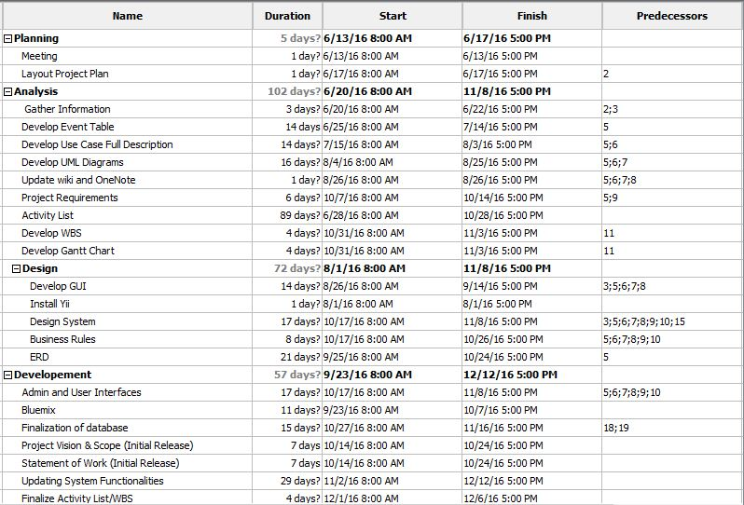

6. Deliverables
Deliverables specified for the project include:

- An acceptable Quality Plan
- An acceptable Change Management Plan (Appendix YY)
- An acceptable Software Requirement Specification
- An acceptable Scope of Work
- An acceptable Project Vision and Scope
- Progress Reports
- User Manual
- Final Paper

7. Review of Quality Plan
The Quality Plan will be reviewed every consortium meeting at least once a month to keep the information produced as reliable, fit for the purpose, consistent with the objectives and deliverables and within the project scope.

8. Document and Record Control
Project documents, records and data will be controlled and stored in GitHub (www.github.com), which is a web-based repository hosting service that offers all the distributed version control and Projects Wiki (www.projects2.apc.edu.ph/wiki) by Jana Gardon, Johanna Heramia and Renzo Tadeo. It will be clearly labelled and made available for consultation by all members of the project team.
The Quality Plan, Project Vision and Scope, Scope of Work, Software Requirement Specification and Change Management Plan will be issued to all members the team.
Project Progress Report will be issued to the following:
- Project Adviser
- Professor

9. Documented Procedures

Software Requirement Specification
LSC Learning Management System

Asia Pacific College
3 Humabon Place, Magallanes
Makati City

Gardon, Jana Marie G.
Heramia, Johanna Marisse C.
Tadeo, Jose Lorenzo Tadeo

December 14, 2016

1. Introduction

1.1 Purpose
The purpose of software requirement specification (SRS) is to provide a full description of the LSC Learning Management System functionalities, the stakeholders, and the requirements to implement the Learning Management System (LMS) so that the Loyola Student Center (LSC), our client, can verify all the necessary content that is included and the team can have the complete understanding in the development of the project.
The following are the objectives of the SRS:
- To serve as a basis for improvement of the finished system
- To provide a realistic basis for estimating costs and schedules
- To provide a basis for developing the software design
- To establish the basis for agreement between the client and the system developers

1.2 Document Conventions
This document is set in Microsoft Word 2016, with a font “Arial” and font size of 11. Each part of the document is written as header 1 and under each part are in header 2; both are in bold property.

Acronym and Abbreviations:
- LMS: Learning Management System
- SRS: Software Requirement Specification
- LSC: Loyola Student Center

1.3 Intended Audience and Reading Suggestions
The intended readers of the SRS document are the following:
- Developers - Developers are those who manage the entire document and system. They may use this document to implement the functionalities and to ensure to be in the right track while doing the system. When there are changes that are needed, they can look through this document for guidance.
- Project Managers - The project manager may use this document to manage the entire LSC LMS such as changes in requirements, resources etc.
- Testers - The testers may use this document to have knowledge on how and what the LMS is capable of doing. They will test the developed system with the given certain cases and estimates the performance of the system.
- Writers of the documents - The document writers may use this document to know the proper flow in creating a document and they are the one that who are going to prepare the user manuals and other necessary documents of the system.
- Users - Users are those who will be needing this system. The users may use this document to have knowledge in the different functions and interfaces of the LSC LMS. They may also use this document to know the difference between LSC-LMS to other existing LMS. This can be used for easy access and familiarization to the system since this system will be used mostly by them. They can also be able to examine the software consequently and could check in this document the suitable requirements and whether developers had implemented all the system’s requirements.

1.4 Scope
The LSC LMS is a software application that aims to improve the current system of LSC in giving tasks, announcing important announcements and tracking of students. It will not a=only benefit the management of the LSC but also the students who enrolled in their classes.
For the students, they will be able to take tasks online, to track their performance based on the results of their tasks, to easily know if there are tasks to do through the calendar and to also track their attendance. For the tutor, they will be able to create courses in classes and add student to that course, to add tasks (in task, the tutor can give on how many attempts the student can have and can also put time limits) and to track the attendance of students.
So, using this LSC-LMS, it can provide better service and chance for the students of Loyola Student Center in passing their targeted school or college and to pass to their exams. For the goal of LSC-LMS, refer to the “Project Vision and Scope Document”.

1.5 References
The following are the references for the documents of LSC-LMS:
- Minimum Requirements for Web Based Applications. (2016, February 26). Retrieved October 22, 2016, from https://support.skyward.com/DeptDocs/Corporate/IT Services/Public Website/Technical Information/Workstation Requirements/Web Based Workstation Requirements.pdf
- Project – LSC Group 2 – 101. Retrieved from http://projects2.apc.edu.ph/wiki/index.php/Project_-_LSC_Group_2_-101
- BS Education Free CSS Template. (2015, December 11). Retrieved from http://www.free-css.com/free-css-templates/page193/bs-education

2. Overall Description

2.1 Product Perspective
LSC Learning Management System aims to improve the existing system of the LSC that enable the student to have access on their class curriculum like exercises and assignments online and enables the admin to save students class information which makes the data more organized. This software can help integrate the system then later be released and accessed. It is used to replace their paper-based existing system and some of functionalities of the LSC-LMS may be similar to other existing LMS, however this system is made only for the LSC student, instructor and admin that has specific requirements requested by the client

2.2 Product Functions
The Loyola Student Center Learning Management System is provided for the LSC Management and for the students. Before the student or employee could do the following, he or she must have an account first. The following are the functions of LSC LMS:
- Employee:
  - Can create a course for review class for the students
  - Can record the student’s attendance during the class
  - Can create and assign task such as assignments, quizzes and exercise
  - Can give announcements through the calendar
  - Can update the student’s grades
- Student:
  - Can access the review class
  - Can view their attendance
  - Can take tasks
  - Can see the announcements through calendar
  - Can keep track with their grades
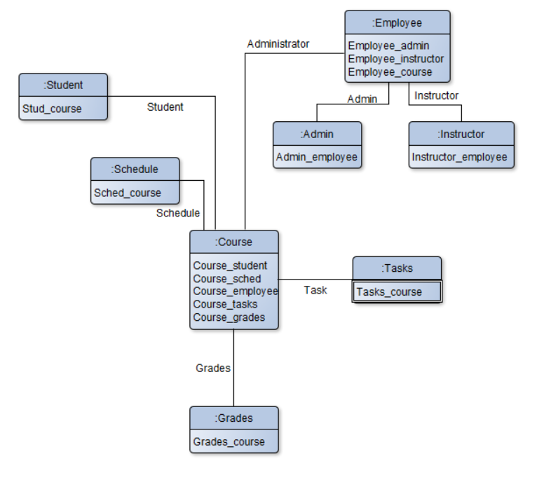

2.3 User Classes and Characteristics
There are three kinds of users that are expected to use the LSC-Learning Management System. Each kind of user has their own roles and should perform different operations within the system.
- Administrative staff (or System administrator), users with the LSC LMS administrator knowledge
- Tutors or Lecturers, users with LSC LMS usage knowledge
- Students, users with LSC LMS usage knowledge
The administrator must be familiar with the web applications and shall configure the environment for the rest of the users who does have the LSC LMS database knowledge or information so they can use the LSC LMS without problems.
Tutors or lecturers should have at least basic knowledge in managing computer devices. The professors or lecturers will be the one who will create courses and will manage the students’ records in class such as checking of the attendance and who will give assignments, exercises or quizzes to classes.
Students should have at least basic knowledge on what the LMS can do. The students can use the LMS to view their records and take tasks such as assignments, quiz, or exercise.

2.4 Operating Environment
OE_1: The LSC LMS shall operate with any web browser and It is recommended that it is in the latest version.
OE_2: The LSC LMS shall operate on Windows, iOS, Linux and Android operating system
OE_3: The LSC LMS can be accessed by any LSC students or personnel.
OE_4: The LSC LMS backend can only be accessed inside the LSC premises only.
OE_5: Minimum hardware requirements: Dual Core 1.6GHz of faster. RAM: 1 gigabyte (GB) (32-bit) or 2 GB (64-bit).

2.5 Design and Implementation Constraints
The LSC students and admin can use this system because the information must be kept within LSC-LMS users only. While the students are taking the exam, right click is invalid to avoid printing the questions.
DaIC_1: The LSC Learning Management System design’s and functionalities shall adapt or modify the process of the current system of LSC.
DaIC_2: The LSC Learning Management System must follow the given requirements of the client.
DaIC_3: The LSC Learning Management System must perform validation checks in user’s input
DaIC_4: The materials that will be using online should not printable or not right clickable for the students to be able to not to share it online or with anyone.
DaIC_5: The system uses PhpmyAdmin MySQL for the database.
DaIC_6: The system uses Yii2 (advance template) and Admin LTE (theme in backend) to build the system.
DaIC_7: PHP, CSS and JavaScript are being combined in creating the system interfaces.

2.6 User Documentation
Together with the LSC LMS, for the user of it to be able to understand on how does it work and what are the usage of the system, user manuals will be written and provided under the client’s perspective and understanding. The readers of manuals are being assume that they are nontechnical readers thus, every terminology are easy to understand. The user manual includes step-by-step procedures.

2.7 Assumptions and Dependencies
A_1: Once the student is enrolled he or she can already have a LSC account. There’s no need for the student/guardian to sign-up on their own.
A_2: They can take exercises and assignments, and can view the results and grades.
A_3: It let the student to monitor their attendance as the instructor will check the attendance using LMS.
A_4: The student can be notified when there are upcoming events and tasks in the calendar page.
A_5: Since it is an account, there is a profile page that contains personal information of the student.
A_6: The instructor can add tasks and events on each of the student’s account.
A_7: The admin can update the information in the system.
A_8: The admin/instructor can have their own account on the backend side.
D_1: A student must enroll first to have a LSC-LMS account.
D_2: It must be connected to the internet to access it.
D_3: A browser is needed to access and view the system.
D_4: Management efficiency to meet the client’s satisfaction.

3. External Interface Requirements

3.1 User Interfaces
Here are some of the screenshots of the interfaces of LSC LMS.
Frontend
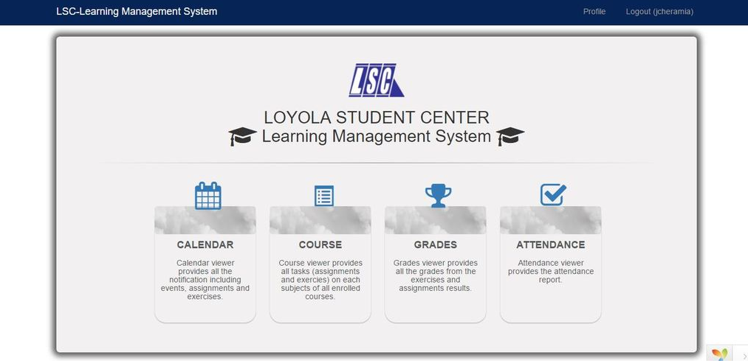
Figure 1. Main Page
This is the sample main page for the student in frontend. There are four sections: calendar, course, grades and attendance. In calendar, the student can check their schedule of their classes and also if there are tasks that they need to do. The calendar will as the reminder for the students. Next is the course. In this section, the student can see their courses that their tutor created. Then for the grade section, the student can see their grades of their different tasks. Lastly the attendance. The student can see their attendance in a specific course. This section will let them know if how many absences they had in the past.

Backend
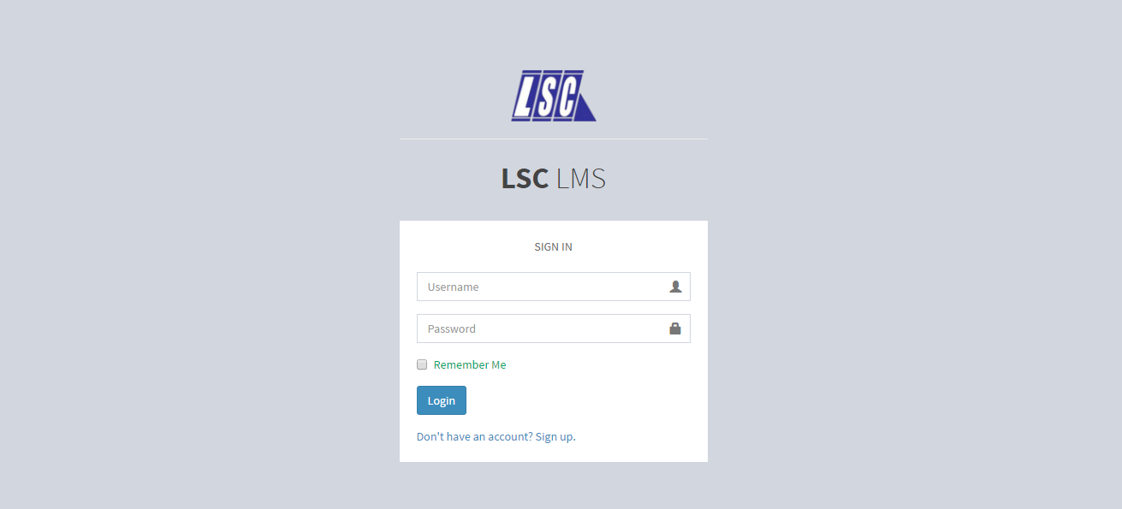
Figure 2. Login Page
This is the login page for the backend side. The backend side is only accessible within the LSC premises only.

3.2 Hardware Interfaces
For client side:
Hardware: Minimum System Requirement
Processor: at least 1.3 GHz processor or faster
Memory: 128 MB RAM (256 MB recommended)
Disk Space: 80GB or above
Screen resolution: at least 800 x 600 colors or above

For web server side:
Item | Web server (minimum) | Web server (recommended) | Combined Web & Database Server (minimum) | Combined Web & Database Server (recommended)
Processor | 1.6 Ghz | 2 x 1.6 GHz CPU | 2 x 1.6 GHz CPU | 4 x 1.6 GHz CPU
RAM | 1.75 GB RAM | 3.5 GB RAM | 3.5 GB RAM | 7 GB RAM
HDD | 1x 40 GB of free space or more is recommended.  1x 40 GB of free space or more is recommended for the software.

3.3 Software Interfaces
The needed software interfaces to use the LSC-LMS are the following:
- Windows, Linux, iOS and Android operating system environment
- The graphical user interfaces and other parts of LSC LMS software are to be done using the Yii2 advanced framework. It uses HTML, CSS, PHP 5.4, Bootstrap, JQuery etc.
- The output of the software will need a browser (e.g. Chrome, Internet Explorer, Firefox) for viewing it.
- The database in use is MySQL
- The LSC LMS is dependent to the LSC Enrollment System, so it must be integrated with the Enrollment System.

3.4 Communications Interfaces
- Internet connection and a browser are required.
- Client on Internet will be using HTTP/HTTPS protocol

4. System Features

4.1 Creating course
4.1.1 Description and Priority
The admin or lecturer provides the students courses to access the learning materials of a review class. The priority of creating a course is High.

4.1.2 Stimulus/Response Sequences
- Stimulus: The admin/lecturer creates new course
- Response: The added course will be inserted in the database and the page will display

4.1.3 Functional Requirements
REQ-1: The admin/lecturer should have an account
REQ-2: The admin/lecturer should be connected to the internet

4.2 Adding tasks

4.1.1 Description and Priority
The admin/lecturer adds tasks such as assignments and exercises for the student. The priority of adding a task is Medium.

4.1.2 Stimulus/Response Sequences
- Stimulus: The admin/lecturer access the course link
- Response: The course page is displayed
- Stimulus: The admin/lecturer adds a task
- Response: The added course will be inserted in the database and the task page will display

4.1.3 Functional Requirements
REQ-1: The admin/lecturer should have an account
REQ-2: There should be an existing course

  - Making announcement in calendar

4.3.1 Description and Priority
The admin/lecturer can make announcement the calendar. The priority of making an announcement in calendar is Low.

4.3.2 Stimulus/Response Sequences
- Stimulus: The admin/lecturer access calendar link
- Response: The calendar page will display
- Stimulus: The admin/lecturer will select a date and add an announcement
- Response: The announcement will be displayed inside the selected date
4.3.3 Functional Requirements
REQ-1: The admin/lecturer should have an account

  - Listing attendance

4.4.1 Description and Priority
The admin/lecturer can list the attendances of the students whether he or she is present during the class. The priority of listing the attendance of the student is High.

4.4.2 Stimulus/Responses Sequences
- Stimulus: The admin/lecturer access the attendance link
- Response: The attendance page will display
- Stimulus: The admin/lecturer select’s a student and updates his or her status during the class
- Response: The updated status of the student will be saved in a database to keep track of the student’s attendance
4.4.3 Functional Requirements
REQ-1: The admin/lecturer should have an account
REQ-2: The admin/lecturer should be enrolled in the review class
REQ-3: The student should have an account
REQ-4: The student should be enrolled in the review class of the lecturer

5. Other Nonfunctional Requirements

5.1 Performance Requirements
- The response of the system depends on whether the internet connection is slow or fast.
- The system shall display a confirmation message or result to users right after the user submits his or her answers in the exercises and assignments.
- The calendar will notify when there is an upcoming event or task to do.
- The system should generate policy with an accuracy of 99%
- The time and date when the user pass the task or the instructor adds task and event, and delete task, depends on the time and date on the user’s device.

5.2 Safety Requirements
The LSC LMS must only be authorized by LSC students, admin and instructors only. All the information is restricted and must not access by non-LSC students and employees. All the exercises and assignments must be secured well. During taking the task, the user can’t right click the page to avoid printing the questions. There is a consistency since the system is connected to only one server.

5.3 Security Requirements
The security requirement of the LSC are, only the approved students of the LSC can access the LSC-LMS and the task that will be given by LSC such as assignments and exercises should not be printed or saved in any devices. The team’s solution for both security requirements are, the students email and password will be created when the administration of the LSC approved of his or her account. The information is secured and accessed only between LSC students and employees only since the students can only have an account when he/she is already enrolled. Moreover, there will be no access to LMS once the student is already unenrolled. Regarding with the task security, the team came up with the solution of “not right clickable” making the task unprintable and not downloadable.

5.4 Software Quality Attributes
5.4.1 Security
- The LSC LMS will run inside a firewall for security.
- The LSC LMS will support different roles for users such as tutors, students and system administrator. The user logged in with given role should only be allowed with that role (e.g. Student will only be allowed to see his or her grades not to change it.).
- In HTTPS, it enables access to web application to secure access of the confidential data such as the student’s data. The Administrator of LSC LMS will have full database administration control and tutors may have access to copy of some parts of database for editing purposes.
- The LSC materials for quizzes shall not be printed
5.4.2 Reliability
- The LSC LMS images should be clear and understandable.
- The system shall not be down for more than three times a year.
5.4.3 Scalability
- The LSC LMS must be scalable to a large number of users since courses will have hundreds of students.
5.4.4 Availability
- The LSC LMS must be available 24 x 7 so that student and tutors can use it any time.
5.4.5 Responsiveness
- Less responsive time must be there so that the users will feel good while using the system.

5.5 Business Rules
LSC Learning Management System will be used by the LSC students, instructor and admin. The student will automatically have a LSC-LMS account once he/she is already enrolled. The admin is responsible on the update of the personal information of the student while the instructor add course, subjects, tasks, events and check attendance to each of the student’s account. The following are the step by step business rule of the LSC LMS:
- It is already assumed that student and tutor has an account already when logging in to the system.
- The tutor will create a course and add students to it.
- The tutor will check attendance
- The tutor will create task such as quizzes, homework or exercise
- The student will be notified that there are tasks that is needed to be done
- The student can now take the tasks given by the tutor, then after taking the task there will be a result page. In a result page, student can see their grades, minimum and maximum grades.
- The student can view their attendance and to check to know for example their number of absences.

Statement of Work
LSC Learning Management System

Asia Pacific College
3 Humabon Place, Magallanes
Makati City

Gardon, Jana Marie G.
Heramia, Johanna Marisse C.
Tadeo, Jose Lorenzo Tadeo

December 14, 2016

Introduction/Background
Loyola Student Center (LSC) approved the project Learning Management System (LMS) to improve their current system in providing better services to their customers. The LMS main objective is to provide better service to their customer and to lessen their expenses by giving less papers to their customers. The LMS will have a user friendly interface for their customer and staff easily familiarized. The contents of the LMS can be used to submit assignments, take exercises willingly, view their schedule and calendar for announcements, and keep track with their performance and attendance. Using the LMS can improve the LSC service such as handing out assignments through online, providing the customer’s performance through the results, and informing the customers immediately through calendar. LSC group 2, the developers of LSC LMS seeks to implement the system in the organization’s area for better evaluation of the LSC LMS. LSC can anticipate that their new system can make their work more efficient both the employees and the customers.

Scope of Work
The scope of work of the LSC Learning Management System includes all planning, execution and implementation for improving the existing process of the Loyola Student Center(LSC) on managing or administrating students’ records such as their attendance, quizzes and their grades. The system will also help the student to monitor their performance based on their grades on their quizzes and exercises and this new system was based on the feedback and additional requirements that the LSC provided. Before designing the system, the development team must ensure that the database is all correct such as proper relationships, proper entities, and proper attributes. Specific deliverables and milestones will be listed in the Work Requirements and Schedules and Milestones sections of this SOW.

Period of Performance
The period of performance for the LSC Learning Management System is within 6 months beginning on June 2016 through the third week of December 2016. All works must be scheduled to complete the system development within this timeframe. Any changes or extensions will be requested through the LSC for review and discussion.
.

Place of Performance
The Loyola Student Center – Learning Management System developing members will perform a majority of its work at its own facility. They may meet with the LSC for meeting. All project gate reviews will be held at LSC’s facility and attended by the developing team. LSC will provide and arrange for meeting spaces within its facility for all required meetings.

Work Requirements
In developing LSC Learning Management System, the development team will be responsible for accomplishing tasks across the different stages of the system. The following is a list of all task which will result in the successful completion of this system:

Beginning:
- The team will create and will present the planning of the system including the Work Breakdown Structure (WBS)
- The team will present the project plan to LSC for review and approval

Design Phase:
- Consultation with the LSC to know their requirements in the system
- Created the system’s design based on the gathered requirements
- Develop and improve the system’s design for LSC review and approval
- Present project status report at weekly meeting

Build Phase:
- The developing team will complete all the coding for approved system’s design
- The developing team will provide LSC with a detailed testing plan or manual
- The developing team will include all requirements provided by the LSC on improving their existing process
- The developing team will conduct testing before implementation of the system
- The developing team will resolve any coding and design issues identified in testing
- The developing team will compile testing report to present to LSC for review and approval
- Present weekly status at weekly meeting

Implementation Phase:
- The developing team will implement the new system of the LSC

Project Handoff/Closure:
- The developing team will provide LSC with all documentation in accordance with the approved project plan
- The developing team will present project closure report to LSC for review and approval
- The developing team will complete the project requirements checklist showing that all project tasks have been completed
- The developing team and the organization will have a meeting whenever changes are made.

Schedule/Milestones
The below list consists of the initial milestones identified for the LSC Learning Management System:

Planning
- Meeting with the team June 13, 2016
- Layout Project Plan June 17, 2016
Analysis
- Gather information June 20, 2016
- Develop Event Table June 25, 2016
- Develop Use case full description July 15, 2016
- Develop UML Diagrams August 4, 2016
- Finalize wiki and One note August 26, 2016
- Develop GUI August 26, 2016
- Develop project functionality August 29, 2016
- Presentation of final project September 5, 2016
- Updating project requirements September 19, 2016
- Finalization of database October 12, 2016
- Updating GUI October 19, 2016
- Project Vision and Scope (initial release) October 14, 2016
- Statement of Work (initial release) October 14, 2016
- Updating system functionality November 2, 2016
- Finalize Activity List/WBS December 1, 2016
- Final presentation December 14, 2016

Acceptance Criteria
The LSC admin will check if all their requirements where met to ensure the completeness of each stage then the acceptance deliverables will reside with head of LSC. After the completion of the project, the developing team provide their report for review and approval. The manager of LSC will either sign off if they will advise what task must still be accomplished.

When the project was already completed, it will enter the closure stage. In this stage, the developing members will provide their project closure report and project task checklist to LSC management. Once the project has been accepted by the LSC it also means that he acknowledges acceptance of all project deliverables and that the developing team has met all assigned tasks. If there are any discrepancies related to the completion of project or disagreement among LSC and the developing team will be referred to both organizations' contracting offices for review and discussion.

Other Requirements
Security is important in the Loyola Student Center specially in their materials for exercises or assignments which restricts non-LSC student to have an access. No print screening, copy pasting or printing of their materials are one of the requirements in security of the LSC in LSC LMS.

Bibliography

Moodle Features. (2016, March 11). Retrieved from https://docs.moodle.org/31/en/Features

Learning Management Systems. (2016). Retrieved from http://www.webanywhere.ph/products/lms

How Learnanywhere benefits Primary schools. (2013). Retrieved from http://learnanywhere.co.uk/features/.

Globio, E. M. (2014). Thesis Paper Guidelines and Policies. Retrieved from http://www.slideshare.net/erwin_globio/bscs-bsit-t

Hardware Requirements for Web and Database Servers. (2014). Retrieved from http://help.sana-commerce.com/sana-commerce-83/installation/setup-web-and-database-server/hardware-requirements-for-web-and-database-servers

